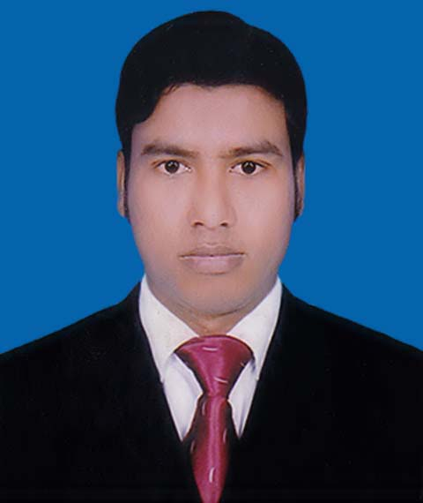
CURRICULUM VITAE
OF
Md. Ziaul Islam
Mailing Address :
C/o : Md. Abdullah
Vill: Mohishal Bari; Post: Mohishal Bari; P.S: Godagari; Dist: Rajshahi.
Contact no: 01724-841151
Email: zislam4552@gmail.com

Career Objective:

Looking for hard and challenging job where I have scope to utilize my potentiality, adaptability and skill to do something innovate and from where I will be able to enhance my knowledge, develop my career and apply interpersonal skill to increase organizational efficiencies.

Educational Qualification:

Secondary School Certificate (S.S.C)
Institution : Masjid Mission Academy, Rajshahi.
Board : Rajshahi.
Passing Year : 2010
Result : G.P.A - 5.00
Group : Science

Diploma-in-Engineering (Four Years)
Institute : Chapai Nawabganj Polytechnic Institute
Board : Bangladesh Technical Education Board, Dhaka
Session : 2010-2011
Passing Year : 2014
Result : 3.09
Department : Electronics Technology.

Computer Skill:

Operating System : Windows 2007
Application Programs : Data Base
Other Skills : Sufficient skills at E-mail & Internet Explore.

Language Skill:
Proficient in communicating, Writing, Reading and Speaking in English and Bengali both.

Experience:
08 Months Working Experience in Global Polytechnic & Engineering Institute, Chapai Nawabganj In Junior Instructor.

Training:
Training - 01
Three months Industrial Training in Walton Service Management System, Rajshahi.
Training – 02
Good command in-
- Microsoft Word, Microsoft Excel
- Internet browsing
- Three Years Long servicing work, Raihan Electronics, Rajshahi.

Personal Details:

Name : Md. Ziaul Islam
Father’s Name : Md. Abdullah (01729-547405)
Mother’s Name : Sabanur Begum
Brother’s Name : Md. Shohidullah (01716-206037)
Permanent address : Vill: Mohishal Bari; Post: Mohishal Bari
P.S: Godagari; Dist: Rajshahi.
Current Location : Vill: Mohishal Bari; Post: Mohishal Bari
P.S: Godagari; Dist: Rajshahi.
Date of birth : 1th November, 1995
Gender : Male
Religion : Islam
Nationality : Bangladeshi
National ID No : 19958123402000736
Marital Status : Unmarried

Dr.Md. Abdus Salam Chowdhury  Vice Principal (In charge)  Chapai Nawabgonj Polytechnic Institute.  Cell: 0781-51771 (Office), 01558-340316  E-mail: dr.abdussalamchowdhury@gmail.com | Md. Sahin Shekh  CTV Officer (ID: 330)  Walton Service Management System,  Rajshahi.  Cell: 01678-028804
References:

Date: Md. Ziaul Islam

